SOCIAL MEDIA TOOLKIT:
IMAGES, HASHTAGS, RESOURCE LINKS, AND DRAFT POSTS IN HAITIAN CREOLE WITH ENGLISH TRANSLATIONS

Hello! This document contains links to all images that can be used with campaign social media posts, hashtags, resource links, and draft posts in Haitian Creole along with their English translations. Please click the included links to download the image files onto your computer and edit if necessary. Please feel free to use posts verbatim, to take parts of the posts, or to simply get ideas from them.
As a reminder, we ask that you post a minimum of one per day (7 posts) during this coming week. However, feel free to post much more often! We also ask that you participate in two social media storms (see campaign introduction email for more details) and share at least one video.

IMAGE BANK
Links to download the following social media images:
About: This resource can be used as images for social media posts for any platform.
To Download: To download please click the link for the image you wish to download below. Right click image, click ‘save image as’, and save to desired folder on your computer.
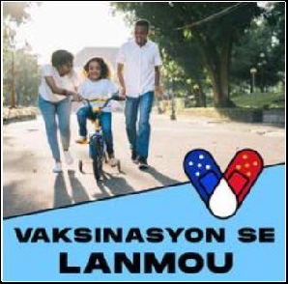
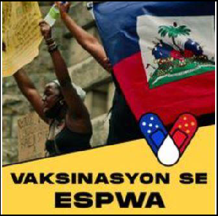
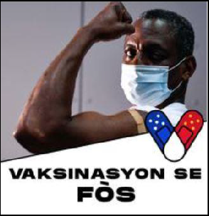
Links:
- Vaksinasyon Se Lanmou
- Vaksinasyon Se Espwa
- Vaksinasyon Se Fòs

English translation of above images and links:
- Vaccination is Love (Blue)
- Vaccination is Hope (Gold)
- Vaccination is Strength (White)

Links to download and edit the following social media image frames:
About: This editable resource allows you to insert a photo of yourself, someone else, or something else in the white space behind the bottom frame/image. Download the image and upload it as a social media profile photo for yourself or your organization or use it as a social media post image for any platform.
To Download: To download click the download link which will contain one file for all three frames. The link will take you to the specific resource link that is also listed on MCN’s campaign page which includes some of the other campaign resources. Clicking the link will automatically download a PowerPoint file onto your computer (it will not open a new window). Please make sure your block-up protection is disabled if the file will not download. If assistance is needed, please contact your campaign contact and the file will be sent to you.
After downloading the file, you have two options to edit it. If you have PowerPoint on your computer, you will be able to edit the file in PowerPoint. If you do not have PowerPoint on your computer, you can edit this file for free by using Google Slides.
To open the document in Google Slides right clicking the document, click ‘open with’, and then click ‘Google Slides’. If this does not work for you, it may be because you do not have a Google Slides Account. If so, please sign up for Google Slides by going here and clicking ‘Go to Google Slides’. To upload the file into Google Slides click on the folder graphic (‘Open File Picker’), click ‘upload’, and upload your file.
The resource includes directions for how to save your final product as an image. If you would like assistance inserting your photo, please contact your campaign contact.
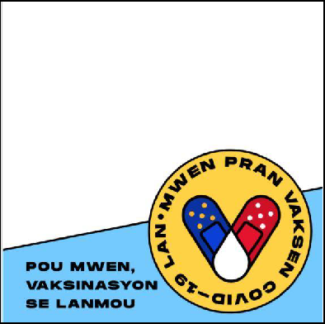
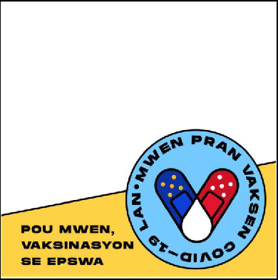
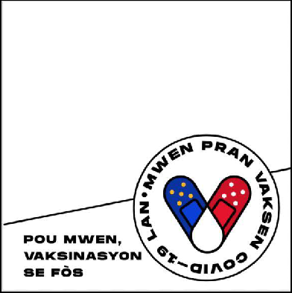
Link:
- Download link for all three resources here.
English translation of above images:
- For me, vaccination is love. (Blue)
- For me, vaccination is hope. (Gold)
- For me, vaccination is strength. (White)
Links to download the following images:
About: These resources include images that can be used for social media posting on any platform, in addition to any other purpose.
To Download: To download please click the link for the image you wish to download. The provided links follow the order of the images below (From right to left, and then top to bottom). The link will take you to the specific resource link that is also listed on MCN’s campaign page which includes some of the other campaign resources. Please right click and select ‘Save Image As’ to download to your computer. If assistance is needed, please contact your campaign contact and the file will be sent to you.
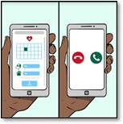
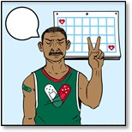
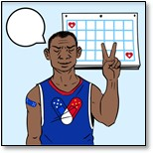
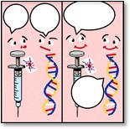
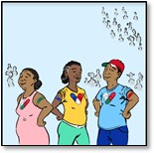
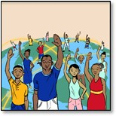
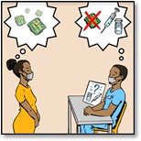
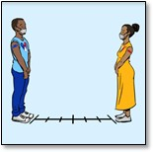
Links:
- Man In Green Shirt Sitting at Table Reading Newspaper
- Man In Blue Shirt Sitting at Table Reading Newspaper
- Phone Image Communicating Vaccine Sign-Up and Timeline of Vaccines
- Vaccinated Man In Green Shirt In Front of Calendar
- Vaccinated Man In Blue Shirt In Front of Calendar
- Vaccine and DNA
- Three Vaccinated People
- People Around the World
- Woman and Man Discussing Hesitancies and Myths
- Vaccinated Man and Woman Social Distancing and Wearing Masks

RESOURCE LINKS
Please share the following video, or a different video that you know of and like.
- (Haitian Creole) You Should Get a COVID-19 Vaccine
HASHTAGS
We ask that you use the ‘official campaign hashtags’ in all of your social media posting if possible. Please see ‘other’ hashtags for more hashtag ideas.
Official Campaign Hashtags:
- #MwenPranL (I Took It)
- #MwenPranVaksenAn (I Get Vaccinated)
- #SanteLakay (home-based health/community health)

Optional Hashtags:
- #VaksinenJodiA (Get Vaccinated Today)
- #KanpeCOVID19 (Stop COVID-19)
- #Mask (Mask)
- #MwenKweNanLaSyans (I believe In Science)
- #CDC

DRAFT SOCIAL MEDIA POSTS IN HAITIAN CREOLE WITH ENGLISH TRANSLATIONS
Below are 15 draft social media posts. Please feel free to use these posts in their entirety, to take parts of the posts, or to simply get ideas from them. The drafts include post topic, post text in Haitian Creole, English translation of Haitian Creole text (see note below), and a list of additional hashtags you are welcome to choose from.
Important Note: English translations for the following posts are NOT intended for social media use. While you may use them if you wish, the intent for providing these translations is for non-Haitian Creole speakers to understand what is communicated in the Haitian Creole posts. Differences in phrasing compared to posts intended for English-language posting may be present since direct translations are used.

DRAFT SOCIAL MEDIA POSTS IN HAITIAN CREOLE WITH ENGLISH TRANSLATIONS
DRAFT POST #1:

Topic: Love

Haitian Creole: Nou pran vaksen pou COVID-19 la pou pwoteje fanmi nou epi pou kenbe moun nou renmen yo ansekirite. #MwenPranL #MwenPranVaksenAn #DelmarvaPranVaksenAn #SanteLakay

Translation In English: We vaccinate to protect our family and keep our loved ones safe. #ITookIt #IGetVaccinated #DelmarvaIsVaccinated #Home-based health/community health

Other Additional Hashtags in Haitian Creole: #VaksinenJodiA (Get Vaccinated Today), #KanpeCOVID19 (Stop COVID-19), #Mask, #MwenKweNanLaSyans (I believe in Science), #CDC
DRAFT POST #2:

Topic: Love

Haitian Creole: Renmen vwazen ou menjan ou renmen tèt ou. Pran vaksen kont COVID-19 la. #MwenPranL #MwenPranVaksenAn #DelmarvaPranVaksenAn #SanteLakay

Translation In English: Love your neighbor as yourself. Vaccinate against COVID-19. #ITookIt #IGetVaccinated #DelmarvaIsVaccinated #Home-based health/community health

Other Additional Hashtags in Haitian Creole: #VaksinenJodiA (Get Vaccinated Today), #KanpeCOVID19 (Stop COVID-19), #Mask, #MwenKweNanLaSyans (I believe in Science), #CDC
DRAFT POST #3:

Topic: Strength

Haitian Creole: L’union fait la force/Ansanm nou fò. Ak chak moun ki pran vaksen an, kominote nou an pran fòs epi viris la vin pi fèb. #MwenPranL #MwenPranVaksenAn #DelmarvaPranVaksenAn #SanteLakay

Translation in English: L’union fait la force. With every person vaccinated, our community gets stronger and the virus gets weaker. #ITookIt #IGetVaccinated #DelmarvaIsVaccinated #Home-based health/community health

Other Additional Hashtags in Haitian Creole: #VaksinenJodiA (Get Vaccinated Today), #KanpeCOVID19 (Stop COVID-19), #Mask, #MwenKweNanLaSyans (I believe in Science), #CDC
DRAFT POST #4:

Topic: Love for Family

Post in Haitian Creole: Lè w pran vaksen, ou pwoteje moun ou renmen yo tou kont COVID-19. #MwenPranL #MwenPranVaksenAn #DelmarvaPranVaksenAn #SanteLakay

Translation in English: By getting vaccinated, you also protect your loved ones from COVID-19. #ITookIt #IGetVaccinated #DelmarvaIsVaccinated #Home-based health/community health

Other Additional Hashtags in Haitian Creole: #VaksinenJodiA (Get Vaccinated Today),
#KanpeCOVID19 (Stop COVID-19), #Mask, #MwenKweNanLaSyans (I believe in Science), #CDC
DRAFT POST #5:

Topic: Love for Community

Post in Haitian Creole: Nan kominote nou, nou pran swen youn lòt. Fè yon diferans. Pran vaksen kont COVID-19 la. #MwenPranL #MwenPranVaksenAn #DelmarvaPranVaksenAn #SanteLakay

Translation in English: In our community, we take care of each other. Make a difference. Get vaccinated against COVID-19. #ITookIt #IGetVaccinated #DelmarvaIsVaccinated #Home-based health/community health

Other Additional Hashtags in Haitian Creole: #VaksinenJodiA (Get Vaccinated Today), #KanpeCOVID19 (Stop COVID-19), #Mask, #MwenKweNanLaSyans (I believe in Science), #CDC
DRAFT POST #6:

Topic: Fight COVID Together

Post in Haitian Creole: Yon kominote ki gen tèt ansanm se yon kominote ki gen fòs. Annou pran vaksen pou nou venk COVID-19 ansanm. #MwenPranL #MwenPranVaksenAn #DelmarvaPranVaksenAn #SanteLakay

Translation in English: A united community is a strong community. Let's get vaccinated to defeat COVID-19 together. #ITookIt #IGetVaccinated #DelmarvaIsVaccinated #Home-based health/community health

Other Additional Hashtags in Haitian Creole: #VaksinenJodiA (Get Vaccinated Today), #KanpeCOVID19 (Stop COVID-19), #Mask, #MwenKweNanLaSyans (I believe in Science), #CDC
DRAFT POST #7:

Topic: Community Unity

Post in Haitian Creole: Ak chak moun ki pran vaksen an, nou renouvle espwa nou pou nou ka reyini ankò antanke yon kominote. #MwenPranL #MwenPranVaksenAn #DelmarvaPranVaksenAn #SanteLakay

Translation in English: With each person vaccinated, we renew our hope of reuniting as a community. #ITookIt #IGetVaccinated #DelmarvaIsVaccinated #Home-based health/community health

Other Additional Hashtags in Haitian Creole: #VaksinenJodiA (Get Vaccinated Today), #KanpeCOVID19 (Stop COVID-19), #Mask, #MwenKweNanLaSyans (I believe in Science), #CDC
DRAFT POST #8:

Topic: Future Possibilities

Post in Haitian Creole: Maryaj, jwèt spò ak danse pral posib lè nou tout fin pran vaksen kont COVID-19 la. #MwenPranL #MwenPranVaksenAn #DelmarvaPranVaksenAn #SanteLakay

Translation in English: Weddings, sports games, and dancing will be possible when we are all vaccinated against COVID-19. #ITookIt #IGetVaccinated #DelmarvaIsVaccinated #Home-based health/community health

Other Additional Hashtags in Haitian Creole: #VaksinenJodiA (Get Vaccinated Today), #KanpeCOVID19 (Stop COVID-19), #Mask, #MwenKweNanLaSyans (I believe in Science), #CDC
DRAFT POST #9:

Topic: No Cost

Post in Haitian Creole: Li pa koute anyen pou ou pwoteje kont COVID-19 la. Pran vaksen jodia! #MwenPranL #MwenPranVaksenAn #DelmarvaPranVaksenAn #SanteLakay

Translation in English: The cost for your safety against COVID-19 is nothing, get vaccinated today! #ITookIt #IGetVaccinated #DelmarvaIsVaccinated #Home-based health/community health

Other Additional Hashtags in Haitian Creole: #VaksinenJodiA (Get Vaccinated Today), #KanpeCOVID19 (Stop COVID-19), #Mask, #MwenKweNanLaSyans (I believe in Science), #CDC
DRAFT POST #10:

Topic: Social Distance and wear mask even after being vaccinated

Post in Haitian Creole: Nou la ansanm jiska lafen. Toutotan nou tout poko pran vaksen an, li enpòtan pou w kontinye mete mask ou. #MwenPranL #MwenPranVaksenAn #DelmarvaPranVaksenAn #SanteLakay

Translation in English: We are in this together until the end. Until we are not all vaccinated, it is important to continue wearing your masks. #ITookIt #IGetVaccinated #DelmarvaIsVaccinated #Home-based health/community health

Other Additional Hashtags in Haitian Creole: #VaksinenJodiA (Get Vaccinated Today), #KanpeCOVID19 (Stop COVID-19), #Mask, #MwenKweNanLaSyans (I believe in Science), #CDC
DRAFT POST #11:

Topic: Some vaccines require one dose, some require two doses

Post in Haitian Creole: Konnen vaksen kont COVID-19 la yo! Vaksen ki mande de doz yo soti nan Pfizer (Fayzè) ak Moderna. Vaksen ki soti nan Johnson & Johnson la mande yon sèl doz. #MwenPranL #MwenPranVaksenAn #DelmarvaPranVaksenAn #SanteLakay

Translation in English: Know your COVID-19 vaccine! The vaccines that need two doses are from Pfizer and Moderna. The vaccine from Johnson & Johnson needs only one dose! #ITookIt #IGetVaccinated #DelmarvaIsVaccinated #Home-based health/community health

Other Additional Hashtags in Haitian Creole: #VaksinenJodiA (Get Vaccinated Today), #KanpeCOVID19 (Stop COVID-19), #Mask, #MwenKweNanLaSyans (I believe in Science), #CDC
DRAFT POST #12:

Topic: Limited side effects

Post in Haitian Creole: Pa enkyete w! Sèl efè segondè li bay yo se doulè nan bra, tèt fè mal, lafyèv oswa frison. #MwenPranL #MwenPranVaksenAn #DelmarvaPranVaksenAn #SanteLakay

Translation in English: Don’t worry! The side effects may only be arm soreness, headache, fever, or chills. #ITookIt #IGetVaccinated #DelmarvaIsVaccinated #Home-based health/community health

Other Additional Hashtags in Haitian Creole: #VaksinenJodiA (Get Vaccinated Today), #KanpeCOVID19 (Stop COVID-19), #Mask, #MwenKweNanLaSyans (I believe in Science), #CDC
DRAFT POST #13:

Topic: Community

Post in Haitian Creole: Vaksen an ka fè nou sivilizé ankò. #MwenPranL #MwenPranVaksenAn #DelmarvaPranVaksenAn #SanteLakay

Translation in English: Vaccination can make us civil again. #ITookIt #IGetVaccinated #DelmarvaIsVaccinated #Home-based health/community health

Other Additional Hashtags in Haitian Creole: #VaksinenJodiA (Get Vaccinated Today), #KanpeCOVID19 (Stop COVID-19), #Mask, #MwenKweNanLaSyans (I believe in Science), #CDC
DRAFT POST #14:

Topic: Health

Post in Haitian Creole: Nou vaksinen pou nou rete en sante. Translation in English: We vaccinate to keep us healthy.

Other Additional Hashtags in Haitian Creole: #VaksinenJodiA (Get Vaccinated Today), #KanpeCOVID19 (Stop COVID-19), #Mask, #MwenKweNanLaSyans (I believe in Science), #CDC
DRAFT POST #15:

Topic: Survival

Post in Haitian Creole: Vaksinen pou nou ka sove. Translation in English: Vaccinate for our survival.

Other Additional Hashtags in Haitian Creole: #VaksinenJodiA (Get Vaccinated Today), #KanpeCOVID19 (Stop COVID-19), #Mask, #MwenKweNanLaSyans (I believe in Science), #CDC

