Student Action with Farmworkers’
Internship and Volunteer Directory

SAF's Internship Directory is a listing of farmworker organizations and agencies that are seeking volunteers and interns to support their work. The directory is national and includes opportunities to work with health clinics, legal services agencies, organizing groups, and education programs. The directory is a free service intended to connect farmworker organizations with potential interns and volunteers. To submit an internship or volunteer opportunity or to browse the directory visit: www.saf-unite.org



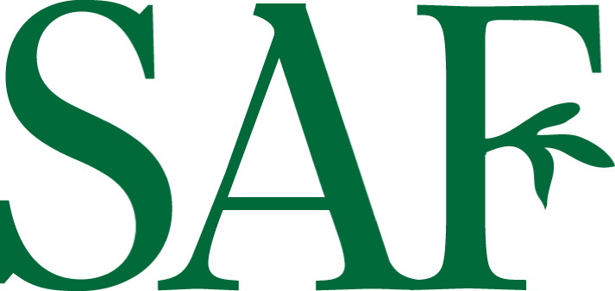
Student Action with Farmworkers is a 501(c)3 non-profit organization whose mission is to bring students and farmworkers together to learn about each other’s lives, share resources and skills, improve conditions for farmworkers, and build diverse coalitions working for social change. SAF accomplishes its mission by coordinating summer internships, providing year-round opportunities for direct service, and carrying out community education, advocacy, and community and labor organizing work.

